Newsletter – May 2024

We have recently made some changes to the way appointment requests are processed when they are received at the practice. With guidance from our Dr Farrington, Dr Clarke and Dr Kenchington we feel the new process is more efficient and safer for patients.

**How can you make an appointment?**

Go to our website [www.solentviewmedicalpractice.co.uk](http://www.solentviewmedicalpractice.co.uk) or the NHS App and complete an eConsult.

Telephone the practice.

Come into the practice and speak to a receptionist.

Some appointments for Blood Tests, vaccinations and some other nurse appointments can be booked using the NHS App.

**What has changed?**

All appointment requests are now reviewed by our clinical team as soon as they arrive.

The clinical team will then let you know of the most appropriate action.

This may be a Face-to-Face appointment, a telephone appointment with a Doctor or Nurse either at the practice or in our Extended Hours Hub. You many need to get some tests done, or you may be directed to another service such as Pharmacy First.

All appointment requests are dealt with in the same way by the clinical team.

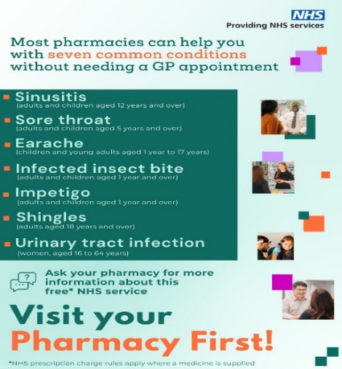

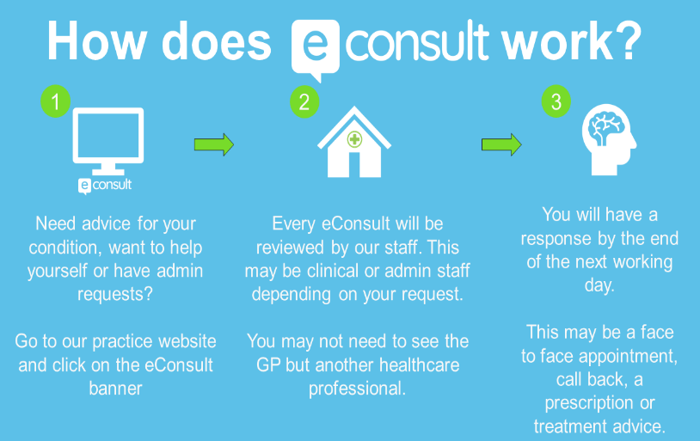

**___________________________________________________________________________**

Have you got the NHS App? If not, it is easy to download. You just need to prove who you are to get full access.

Order repeat prescriptions which are sent straight to the pharmacy of your choice

Book and manage appointments

View your medical record

Use NHS 111 online to answer questions or get instant advice or medical help

Please contact Reception if you would like help using the NHS App.

**___________________________________________________________________________**

**Solent View Medical Practice Patient Participation Group (PPG)**

***What is a Patient Participation Group?***

A PPG is a group of people who are patients of the practice and want to help it work as well as it can for patients, doctors and staff. The NHS require every practice to have a PPG.

***How often do the PPG meet?***

Members of the PPG meet 3 or 4 times a year at the practice. We know that you are busy but hope that you can join us.

***How do I become a member of the PPG?***

This can be done via the practice website [www.solentviewmedicalpractice.co.uk](http://www.solentviewmedicalpractice.co.uk) or please ask a member of our reception team.

**__________________________________________________________________________**

**Are You on a Waiting List for an Appointment, Operation or Treatment at one of our Local Hospitals?**

My Planned Care gives you advice and support while you wait and helps you to prepare for your hospital consultation, treatment, or surgery.

This includes giving you information about waiting times at your hospital and other supporting and local services while you wait.

Your hospital team will be in touch with you as soon as they can. If you are looking for an update, please check this website before contacting your hospital or GP.

The website is updated weekly and is easy to use. [www.myplannedcare.nhs.uk/](http://www.myplannedcare.nhs.uk/)

For QA Hospital please follow the link to South East and Portsmouth Hospitals University Trust

**________________________________________________________________________________**